Polygon Data Collecting Scavenger Hunt

Names of Group Members: Kristie Rosgone, Elizabeth Dufner, Christie McAllister, Audrey Griffin, Cynthia Smith-Kern

Topic/Theme: Geometry, Polygons, Data Collection, Graphs

Level: Fourth Grade

Time Element: Three 40 minute periods

NCTM Standards Addressed:

Geometry Standards

Analyze characteristics and properties of two- and three-dimensional geometric shapes and develop mathematical arguments about geometric relationships

- identify, compare, and analyze attributes of two- and three-dimensional shapes and develop vocabulary to describe the attributes;

- classify two- and three-dimensional shapes according to their properties and develop definitions of classes of shapes such as triangles and pyramids

Use visualization, spatial reasoning, and geometric modeling to solve problems

- recognize geometric ideas and relationships and apply them to other disciplines and to problems that arise in the classroom or in everyday life.

Data Analysis and Probability

Formulate questions that can be addressed with data and collect, organize, and display relevant data to answer them
- collect data using observations, surveys, and experiments

- represent data using tables and graphs such as line plots, bar graphs, and line graphs;

Select and use appropriate statistical methods to analyze data
- compare different representations of the same data and evaluate how well each representation shows important aspects of the data.

Develop and evaluate inferences and predictions that are based on data

- propose and justify conclusions and predictions that are based on data and design studies to further investigate the conclusions or predictions.

PA Math Standards Addressed:

Geometry

2.9.3D Find and describe geometric figures in real life
2.9.5 J Define the basic properties of squares, trapezoids, rectangles, rhombi, and triangles

Data Analysis

2.6.5 A Organize and display data using pictures, tallies, tables, and graphs

PA Math Anchors Addressed:

M4.C Geometry
M4.C.1.1.1 Identify, classify and/or compare two-dimensional figures.

M4.E Data Analysis and Probability
M4.E.1.2.1 Graph data or complete a graph given the data.

Objectives: *Students will be able to name and identify the properties
of two-dimensional figures.

*Students will be able to recognize and identify two-
dimensional figures in their environment.

*Students will be able to collect and organize data using a
frequency table.

*Students will be able to display their data using an appropriate graph of their choice.

Procedure:

DAY ONE:

- Students will be familiar with various polygon shapes including: triangle, square, rectangle, rhombus, trapezoid, pentagon, hexagon, and octagon.
- After a brief review (“Who can tell me a characteristic of a triangle?”), distribute the Polygon Characteristic worksheet.
- Using the worksheet, students will list the previously taught properties of each of the polygons. (Remedial students will be given a Polygon Characteristics Word Bank to use.)
- Teacher and students will review and discuss the worksheet. (ex: Think, Pair, Share activity)
- Distribute the Frequency Chart and Table and explain the procedures for the project using the overhead projector. After the project has been explained and discussed in detail, students will make predictions in their math journal. (Which shape do you think you will find the most in your home? Which shape do you think you will find the least in your home? Explain.

DAY TWO:

- The different types of graphs will be reviewed. For example: If a child suggests a pictograph, ask them to illustrate and explain it on the board.
- After a detailed discussion of graphs, pass out graph paper and rulers.
- Students will choose a type of graph to report their data. (Graphs will be made using the criteria previously learned.)
- When graphs are complete, students will orally share them and then hand them in to be displayed.

DAY THREE:

- Scavenger Hunt Object Discussion-
Ex: What are some of your examples of a triangle/square/rectangle?
- Facilitate discussion with prompts-
Ex: Are you sure? How do you know?
- Wrap-up
-Review properties of each shape
-Bonus questions (spheres, prisms)
-What are some other shapes in your house?

Instructional Strategies and Plan:

Question and Answer
Think Aloud
Higher Order Thinking
Real World Application
Activating Prior Knowledge
Visual-pattern blocks, posters, overhead visuals
Auditory-verbal instruction
Tactile-manipulatives

Materials: Polygon Scavenger Hunt Worksheets, math textbook, graph paper, pencil, crayons, colored pencils, pattern blocks, overhead worksheets and projector

Interdisciplinary Connections:

*Reading-vocabulary and making predictions

*Technology- overhead projector

Assessment Strategies:

*Formative Evaluation: teacher observation and Polygon Characteristic
Worksheet

*Summative Evaluation: Graph presentations and Polygon Characteristic
Worksheet

Correctives/Remediation:

*Preferential seating, small group instruction, Think, Pair, Share approach, provide a “characteristics word bank” for the Polygon Characteristic worksheet, SIOP vocabulary sheet (for any LEP/ESL)

Extensions/Enrichment:

*Add three-dimensional figures to scavenger hunt, design and create a
geometric picture (animal, monster, flower, building, etc.).

Special Accommodations:

*Description of the Special Needs student selected:
Learning Support- student has been identified as L.S. in
mathematics. Student has an average IQ, but is
working below potential.

*Accommodation to use with this student:

Send home pattern blocks

Preferential seating.

Provide Polygon Characteristic Worksheet with given attributes.

SIOP (Sheltered Instruction Operational Procedure) VOCABULARY

ANALYSIS - Evaluation, analisis, evaluacion

ANGLE - Two rays with a common endpoint, angulo

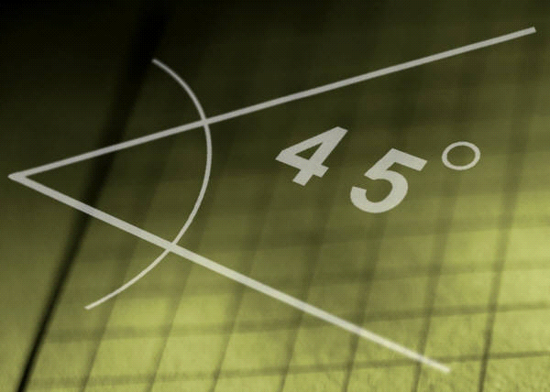

BAR GRAPH - Graph using bars to show data, grafico de barra

DATA - Information, datos, informacion

FREQUENCY - How often an event occurs, frecuencia

GEOMETRY - geometria

HEXAGON - Polygon with 6 sides, hexagono

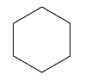

LINE GRAPH - Graph connecting points to show how data changes over
time, linea de grafico

OCTAGON - Polygon with 8 sides, octagono

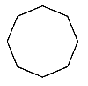

PENTAGON - Polygon with 5 sides

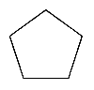

PICTOGRAPH - Graph using symbols to show data, pictografia

POLYGON - Closed plane figure made up of line segments, poligono

PROPERTY – Characteristics of a polygon, de la caracteristica

RECTANGLE - Quadrilateral with 4 right angles and opposite sides parallel
and the same length, rectangulo
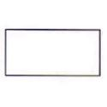

RHOMBUS - Quadrilateral with 2 pairs of parallel sides and all sides the
same length, rombo
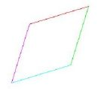

RIGHT ANGLE - Angle that forms a square corner (90°), angulo recto

SQUARE - Quadrilateral with 4 equal sides and 4 right angles,
cuadrado

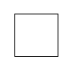

TALLY MARK - Mark used to record data, llevar la cuenta

TRIANGLE - Polygon with 3 sides, triangulo

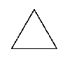

TRAPEZOID - Quadrilateral with exactly one pair of parallel sides,
trapezoide

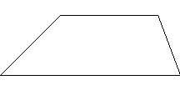

TWO-DIMENSION- Length and width, dimension dos

VERTEX (vertices)- Point where 2 or more edges meet, vertice

Name: _______________________________ Date: __________________

Directions: List the attributes of each polygon.

Polygon Characteristics

*_________________ *___________________

*___________________

*________________________ *_______________________

*________________________ *_______________________

*________________________

*_____________________ *___________________

*____________________ *_______________________

Polygon Characteristics
Word Bank

- 3 sides
- 8 sides
- One pair of parallel sides
- Opposite sides are parallel and same length
- 4 equal sides (2x)
- 2 pairs of parallel sides
- 6 sides
- 4 equal sides
- 5 sides
- 4 right angles (2x)
- No right angles

Polygon Frequency Table

Place a tally mark for each identified shape in the tally column and complete the frequency column.

Polygons | Tallies | Frequency
Triangle

Square

Rectangle

Rhombus

Trapezoid

Pentagon

Hexagon

Octagon

Name ___________________________________ Date ___________________

Polygon Scavenger Hunt
Search your house for the following objects. List them according to their polygon shape in the appropriate column. As you find each shape, complete the Frequency Table attached.

Triangle | Square | Rectangle | Rhombus | Trapezoid | Pentagon | Hexagon | Octagon
 | (ex: clock) | (ex: desktop)

